**INTERNSHIP PROJECT REPORT**

**on**

**Movement Tracker**



**SUBMITTED BY**

**Manomay Dutt Bisht**

**UNDER THE GUIDANCE OF**

**Dr Suchitra Chaudhary**

**Institute for Systems Studies & Analyses (ISSA)**

**Defence Research and Development Organisation (DRDO)**

**Ministry of Defence, Government of India.**

**CERTIFICATE**

This is to certify that the Internship/Training Report titled “Movement Tracker”, conducted from 23/5/2025 to 23/7/2025 submitted by Manomay Dutt Bisht as part of the requirements for the B.Tech. degree in the Department of *Computer Science Engineering* at SRM Institute of Science and Technology is an original record of the candidate's work carried out under my supervision.

I hereby declare that, to the best of my knowledge and belief, this submission represents the candidate's own work. Furthermore, it does not include any content that has been substantially accepted for any other degree or diploma from a university or other institute of higher learning, except where appropriate acknowledgments are provided in the text.

Ms

ISSA, DRDO

**DECLARATION**

I hereby declare that this submission is my own work and to the best of my knowledge and belief, it contains no material that has been previously published or authored by another individual. Furthermore, it does not include any content that has been substantially accepted for the award of any degree or diploma from any university or other institution of higher learning, except where due acknowledgment has been appropriately made within the text.

Signature

Manomay Dutt Bisht

**ACKNOWLEDGEMENT**

I would like to extend my heartfelt gratitude to Ms. Deepakshi Shah, Director of the Institute for Systems Studies & Analyses (ISSA) Laboratory, Defence Research and Development Organisation (DRDO), for granting me the invaluable opportunity to undergo training at this esteemed organization. This experience allowed me to gain exposure to the Research and Development environment and become familiar with Simulation technologies.

I am deeply grateful to Dr Suchitra Chaudhary Ma’am *for his insightful guidance and support throughout the training. My sincere thanks also go to* <*Name*> for giving me additional guidance whenever possible.

Lastly, I wish to express my appreciation to all members of the ISSA group for their constant encouragement, unwavering support, and dedication, which made my training experience truly enriching.

**Manomay Dutt Bisht**  **Ms. Suchitra Chaudhary**

Computer Science Engineering (Mentor)

3rd Year

**ABOUT THE ORGANIZATION  
Defence Research & Development Organisation (DRDO)**

The Defence Research & Development Organisation (DRDO) operates under the Department of Defence Research and Development, part of the Ministry of Defence. DRDO is committed to enhancing self-reliance in defense systems by designing and developing world-class weapon systems and equipment. These advancements align with the expressed needs and qualitative requirements of the three services: The Army, Navy, and Air Force.

DRDO was established in 1958 through the merger of:

The Technical Development Establishment **(TDES)** of the Indian Army, The Directorate of Technical Development and Production (**DTOP),** and The Defence Science Organisation **(DSO).**

The Defence Research and Development Organisation (DRDO) is a network of more than 50 laboratories, dedicated to advancing defense technologies across various domains. These include aeronautics, armaments, electronics, combat vehicles, engineering systems, instrumentation, missiles, advanced computing and simulation, special materials, naval systems, life sciences, training, information systems, and agriculture. The organization is involved in several major projects, focusing on the development of missiles, armaments, light combat aircraft, radars, electronic warfare systems, and more. DRDO has already achieved significant milestones in many of these technologies. As an agency of the Republic of India, DRDO is responsible for the military's research and development, with its headquarters located in New Delhi. In addition to meeting the military's cutting-edge technology requirements, DRDO's innovations provide considerable spin-off benefits to society at large, contributing to national development and strengthening India's defense capabilities.

**Vision**

To make India prosperous by establishing a world-class science and technology base, and to provide our Defense Services with a decisive edge by equipping them with internationally competitive systems and solutions.

**Mission**

* To design, develop, and lead the production of state-of-the-art sensors, weapon systems, platforms, and allied equipment for our Defense Services.
* To provide technological solutions to the Services, optimizing combat effectiveness and promoting the well-being of the troops.
* To develop infrastructure, nurture committed quality manpower, and build a strong indigenous technology base.

**Institute for Systems Studies & Analyses (ISSA)**

ISSA is involved in System Analysis, Modeling & Simulation for various defence applications pertaining to employment/deployment, tactics & force potential evaluation, tactical/strategic & mission planning etc. We develop war games for all the three Services.

Consequent to the reorganization of the system analysis activities within DRDO, the functions of DSE were redefined and was given the present name, i.e. Institute for Systems Studies & Analyses (ISSA) in the year 1980. In the year 1972, a small group named as Aeronautical Systems Analysis Group (ASAG) was created with an objective to carry out aeronautical systems studies and analyses.

This group was functioning from National Aeronautics Laboratory, Bangalore as a detachment of the Directorate of Aeronautics. In the year 1974, ASAG was converted into a self-accounting full-fledged unit named as Centre for Aeronautical Systems Studies & Analyses (CASSA) and was shifted to the premises of Aeronautical Development Establishment, Bangalore.

From 1974 to 2003, CASSA contributed significantly to a series of systems analysis studies attributed to DRDO HQrs and the Indian Air Force. It contributed into several design and development activities and policy level issues with its objective analyses.

In the year 2003, CASSA was merged with ISSA with an objective to synergies systems analysis activities and wargaming development processes under integrated combat environment. With this, ISSA has emerged as a nodal system analyses lab and in 2013 ISSA is placed under SAM Cluster with the mandate in the field of Training & Planning Wargames, Integrated Air Defence & EW, Combat Modeling, Simulation System Analysis and computerised Wargame.

**Area Of Work**

* Modeling, Simulation, Systems Analysis for Defence Application
* Systems Evaluation Studies
* Combat Model Development
* Computer Science and Applications for Defence Modelling & Simulation Domain
* Operations Research and Decision Support Techniques.

**Vision**

* Transform ISSA into centre of excellence in system analysis, modelling & simulation of defence systems to meet the challenges of the present and future requirements of the armed forces.

**Mission**

* Conduct system study and develop high quality integrated software for system analysis & decision support in application areas of Sensors & Weapons, Electronic Combat, Land & Naval Combat, Air-to-Air Combat and Air Defence for effective use by DRDO and Services for Design, Mission Planning, Tactics development and Training.

CONTENTS

1. INTRODUCTION
   1. PROBLEM STATEMENT 4
   2. PROJECT GOALS AND OBJECTIVES 5
   3. SCOPE DEFINITION 6
   4. REPORT OVERVIEW 6
2. LITERATURE SURVEY 8
   1. LITERARY SURVEY 8
   2. *THEORETICAL UNDERSTANDING* 12
3. METHODOLOGY AND SOFTWARE REQUIREMENTS 20
   1. METHODOLOGY 20
   2. SOFTWARE REQUIREMENTS 21
4. IMPLEMENTATION 22
   1. BACKEND 22
   2. FRONTEND 23
5. RESULT AND ANALYSIS 31
6. CONCLUSION AND FUTURE PROSPECTS 32

REFERENCES

**INTRODUCTION**

Problem Statement

Individuals and organizations involved in route planning, terrain analysis, or mobility assessment often struggle to understand how variations in elevation and slope affect movement across a landscape. Traditional 2D maps fail to represent the three-dimensional characteristics of the terrain, making it difficult to anticipate physical obstacles, evaluate route feasibility, or estimate travel durations influenced by uphill or downhill conditions.

There is a clear need for a tool that enables users to define movement paths interactively on realistic terrain data, simulate the corresponding journeys, and visualize how elevation and slope impact movement dynamics. Such a tool would significantly enhance the ability to plan, analyze, and understand travel over diverse and complex terrain.

Project Goals and Objectives

**Project Goal**

To build a web application that helps users simulate and visually understand how terrain elevation and slope affect movement paths and speed.

**Key Objectives**

**1. Visualize Movement Paths:**

Users can draw custom routes on a map that uses real-world elevation data (DTED-1). This lets them choose exactly where the journey should start, end, and pass through.

**Detail:** Using an interactive map, users can set a starting point, add waypoints if needed, and mark the final destination to define the path they want to analyze.

**2. Simulate Journeys Based on User Input:**

Users can set parameters like speed for their chosen routes. The app uses this information—along with elevation data—to simulate how a journey would unfold over that terrain.

**Detail:** It calculates how slope affects movement speed and travel time by analyzing elevation changes along the path.

**3. Display Animated Points and Highlight Terrain Impact**

The simulation brings the path to life by showing a moving point that represents the traveler and by highlighting segments of the path based on slope.

**Detail:** As the point moves, the path is visually updated—colors or line thickness show where the terrain is steep or flat—so users can quickly see how the landscape affects movement.

**4. Improve Terrain Awareness and Planning**

The app helps users better understand how hills, valleys, and slopes impact travel, making it easier to plan smarter routes.

**Detail:** Watching the animation slow down on steeper sections and change visually based on elevation gives users an intuitive feel for how terrain shapes the journey—something a flat map can’t provide.

Scope Defination

1. Terrain Data Integration (DTED-1 Support):  
The application loads and processes elevation data from a Digital Terrain Elevation Data (DTED-1) file—specifically, a pre-defined file n25_e077_converted.dt1 was used for testing the entire project. This data is parsed to extract elevation values, geographical bounds, and resolution, enabling accurate terrain-based simulations.

2. Interactive Map with Terrain Display:  
Users are provided with a grayscale visual map where elevation is represented visually. They can click to select points, draw paths, and see how the elevation varies across the terrain.

3.Path & Journey Configuration:

Users can define a starting point, add intermediate points, set speed parameters, and finalize paths through a sidebar interface. Each defined path is stored along with associated speed values for use in the simulation.

4. Movement Simulation Engine:  
Once paths are defined, the system calculates simulated movement along those routes. It considers terrain slope at each segment and adjusts speed accordingly (e.g., slower uphill, potentially faster downhill). Movement is calculated at regular intervals based on the total segment count.

5. Animated Visualization of Travel:  
The simulation results are displayed as animated points traveling along the defined paths. Additionally, visual cues (like color changes) highlight terrain impact—showing where the path is steep or flat—so users can intuitively grasp how elevation changes affect movement.

6. Coordinated Component Workflow:  
A central component (Main View) manages interaction between the map, simulation timeline, and sidebar. It handles mode changes, passes user interactions, and ensures the right data flows between components.

**Out of Scope:**

* Automated Pathfinding: Users manually define their own routes; the application does not suggest or compute optimal paths.
* Real-Time or Live Data: The application uses static elevation data from a single DTED file and does not integrate live terrain or environmental data.
* Terrain Editing or Modification: Users cannot modify elevation values or simulate changes to the terrain.
* Support for Arbitrary DEM Files: The system currently supports only a specific DTED-1 file and is not built for dynamic uploads or global terrain visualization.

Report Overview

This project is intentionally designed with a clear and focused purpose: to help users better understand how terrain—especially elevation and slope—affects movement across a landscape. Instead of trying to be a full-scale GIS platform with global datasets and complex tools, it zeroes in on a specific region using a static DTED-1 (Digital Terrain Elevation Data Level 1) file. This keeps things simple, purposeful, and easier to explore.

Users don’t need to worry about navigating through overwhelming layers or data. They work with a high-resolution, pre-loaded slice of terrain where they can define routes, set movement speeds, and watch as the application simulates how someone would realistically move across that landscape. Steep climbs slow things down, downhill sections speed them up, and the route itself is highlighted to show these shifts—making the effects of terrain easy to see and understand.

Because of its focused design, the application is especially useful in educational and planning settings. Whether it's students learning about elevation, researchers studying terrain impact, or planners sketching out potential routes, the tool offers a hands-on, visual way to explore how real terrain shapes movement.

At its core, the project is about making complex elevation data feel intuitive. It takes a flat map and brings it to life—helping users move from just “looking at” terrain to actually “experiencing” it through simulation.

**LITERATURE SURVEY**

Literary Survey

Understanding terrain and its influence on movement has long been a subject of interest in fields ranging from geography and cartography to military logistics and civil planning. The foundation of this project rests on the study of Digital Elevation Models (DEMs), specifically the Digital Terrain Elevation Data (DTED) format, which is a standardized method of representing the Earth's surface in digital form. Developed initially by the United States Defense Mapping Agency, DTED serves as a critical data source in various navigation, simulation, and analysis systems.

According to the National Geospatial-Intelligence Agency (NGA), DTED data is arranged in a regular grid structure, with elevation values provided at specific intervals. Level 1 DTED (DTED-1), which is used in this project, offers a post spacing of approximately 3 arc seconds (around 90 meters), giving a moderate resolution suitable for regional terrain analysis and simulation. This data format is well-documented in military cartographic standards and remains a go-to format for elevation-based simulation where performance and simplicity are prioritized.

Several academic sources and textbooks on GIS (Geographic Information Systems) also elaborate on the role of DEMs in terrain modeling. These sources highlight the importance of slope, aspect, and elevation in route planning, watershed analysis, and environmental modeling. For example, in "Geographic Information Systems and Science" by Longley, Goodchild, Maguire, and Rhind, DEMs are discussed extensively as a primary input in terrain analysis, often combined with algorithms that analyze gradient and directionality.

Additionally, this project draws conceptual support from user interaction design principles discussed in HCI (Human-Computer Interaction) literature. Making complex elevation data approachable for end-users—by simplifying workflows like path drawing, simulation triggering, and result visualization—follows from ideas expressed in works like "Designing Interfaces" by Jenifer Tidwell, which advocates for direct manipulation interfaces that match user mental models.

Theoretical Understanding

The theoretical foundation of this project is rooted in several interrelated domains: digital elevation modeling, slope-based motion analysis, spatial data representation, and user interaction design. At its core, the project relies on Digital Terrain Elevation Data (DTED), which represents the Earth's surface as a grid of elevation values. Each data point in a DTED file corresponds to a geographic location (latitude and longitude) and an associated elevation, measured in meters above sea level. By loading this structured dataset into memory, the application can interpolate the elevation at any arbitrary point, forming the basis for terrain-aware calculations. A key theoretical concept used in this project is the slope, which is derived from changes in elevation between consecutive points on a path. The slope between two points is computed as the ratio of the vertical elevation difference to the horizontal distance between them. This slope influences movement dynamics, as traversing uphill generally requires more time or energy than moving downhill or on flat terrain. In our simulation, this relationship is modeled by adjusting the effective speed of travel along each segment based on its slope value—an abstraction based on terrain traversal models used in logistics and energy-efficiency studies.

In terms of spatial representation, this project operates within a two-dimensional coordinate plane while incorporating a third dimension—elevation—into its calculations. Users define paths in 2D space, but the application retrieves and applies 3D elevation data to each coordinate, effectively turning a flat map into a terrain-aware simulation surface. On the visualization front, the animated movement of a point across the user-defined path is driven by discrete time-step simulation. For every small time increment, the position of the simulated entity is recalculated based on the local slope and user-defined speed. Visually, this creates an intuitive understanding of how terrain affects movement—segments with steep ascents slow the animation, while smoother or downhill regions may appear faster. Finally, from a software perspective, the project reflects principles from event-driven architecture and component-based design. Components like the sidebar (for user input), the canvas-based map (for elevation display and interaction), and the timeline (for simulation) all operate independently but communicate through structured data flow and state management—echoing theoretical models used in modern frontend development.

**METHODOLOGY AND SOFTWARE REQUIREMENTS**

Methodology

The methodology for this project follows a modular, component-driven, and user-centric approach. The primary goal was to create a web-based application that simulates movement across terrain, influenced by elevation and slope, using a static DTED-1 file.

**1. Terrain Data Loading**

* The application begins by loading a DTED-1 file (n25_e077_converted.dt1) using a custom DEM Data Service.
* It parses the binary elevation data and calculates metadata such as pixel size, geo-location bounds, and min/max elevation.
* This data is made accessible across components for rendering and simulation.

**2. Map Rendering & User Interaction**

* A canvas-based rendering approach is used in the DemDisplayComponent to display elevation as a grayscale image.
* Users interact with this display by clicking to define a path:
* The **starting point** is selected first.
* Then, **intermediate path points** are added to complete the route.
* The interface visually marks selected points and connects them with lines to define the path.

**3. Sidebar-Based Input Workflow**

* The SidebarComponent manages the user workflow:
* Enables modes such as “add point” or “define path.”
* Allows users to input speed values for each path.
* Handles path finalization and simulation trigger logic.
* All input is validated before progressing to simulation.

**4. Slope-Aware Simulation**

* The TimelineComponent is responsible for calculating and animating the simulated journey:
* Based on the elevation difference between points, slope is calculated.
* Speed is adjusted dynamically using slope—steeper slopes slow down movement.
* The simulation outputs an animated marker traveling along the route.

**5. Visualization & Feedback**

* During simulation:
* An animated point moves along the user-defined path.
* Path segments are color-coded based on slope values to visually indicate difficult terrain.
* Users can redo simulations, reset paths, or modify their input as needed.

Software Requirements

This project is built using a combination of front-end and back-end technologies, geospatial tools, and developer utilities. The software environment was carefully chosen to support elevation data handling, terrain visualization, and path simulation through modern web technologies.

Below is a detailed breakdown of the software tools and their specific versions used in this project:

**1. Programming Platforms & Runtimes**

* **JDK 17** – For any Java-based operations or backend extensions.
* **Node.js 18.16.0** – JavaScript runtime used for running Angular and managing development tooling.
* **NPM 9.5.1** – Node Package Manager used for installing Angular, Tailwind CSS, and other dependencies.

**2. Frontend Development Tools**

* **Angular 15.1** – Primary framework used for building the web interface.
* **PrimeNG 15.4.1** – UI component library used alongside Angular for enhanced design.
* **Tailwind CSS (v3.4.17)** – Utility-first CSS framework for building responsive UI layouts.
* **DaisyUI (v5.0.43)** – Tailwind CSS component library for styled and accessible elements.
* **VS Code IDE 1.78.2** – Main code editor used for development.

**3. Geospatial & Simulation Tools**

* **geotiff 2.1.3** – Library for parsing GeoTIFF formats (available for future data format support).
* **Geoserver 2.24** – If backend geoservices are used for serving DEM tiles or PostGIS layers.
* **OpenLayers 8** – Library for rendering and interacting with geographic maps.
* **Cesium 1.107.1** – (Optional) 3D globe engine for advanced terrain or visual overlays.
* **GeoTools 30.1** – Java-based geospatial library used for parsing and managing spatial data.
* **PostgreSQL 14.0.1 with PostGIS 3.1.4** – For spatial database functionality, if backend support is needed.

**5. Testing & API Tools**

* **Git 2.41.0** – Version control system used to manage and collaborate on the codebase.

**6. Angular Project Dependencies (from package.json)**

* These dependencies are used to build and style the Angular application:
* **@angular/core, @angular/forms, @angular/router** – Core Angular packages used for application logic and routing.
* **rxjs ~7.8.0** – Reactive programming library used in Angular.
* **typescript ~4.9.4** – Type-safe language used in Angular development.
* **zone.js ~0.12.0** – Required for Angular change detection.
* **karma & jasmine-core** – Testing frameworks for unit tests.

**System Requirements**

* **OS**: Cross-platform – Linux, Windows, or macOS
* **RAM**: Minimum 4 GB
* **Browser**: Chrome, Firefox (latest versions)
* **Local Server**: Angular dev server using ng serve

**IMPLEMENTATION**

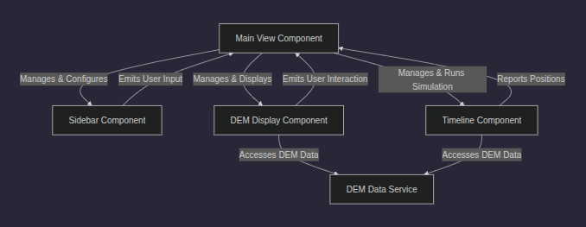

Backend

dem-data.service.ts: Provides DTED-1 computed data to all other functions across all other files.

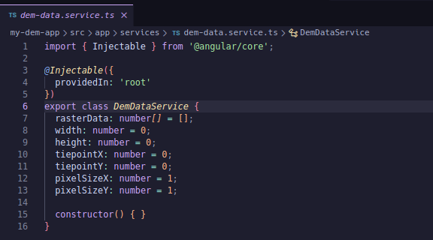

Frontend

Main-view.component.html: Parent component of both sidebar and dem-display and timeline component

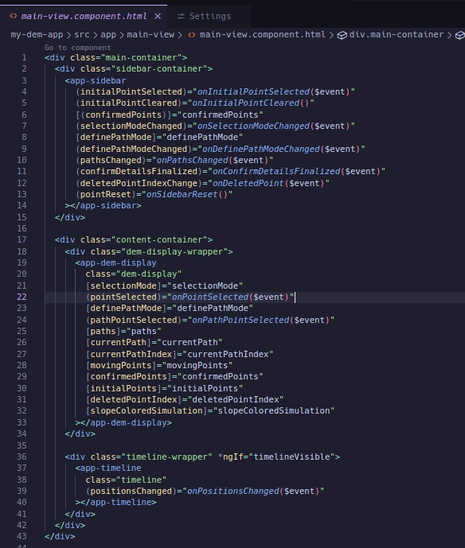

Sidebar.component.ts: Basically, has functions that define purpose and action for each button which helps in committing action on the canvas

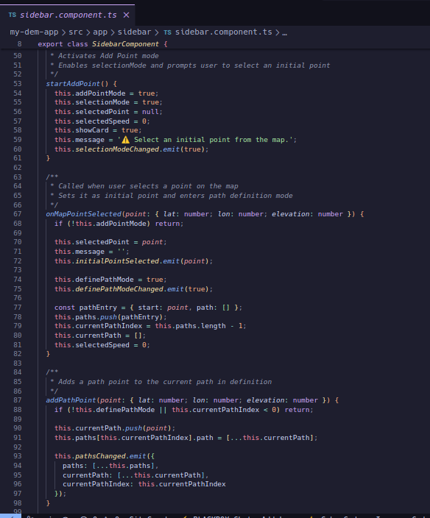

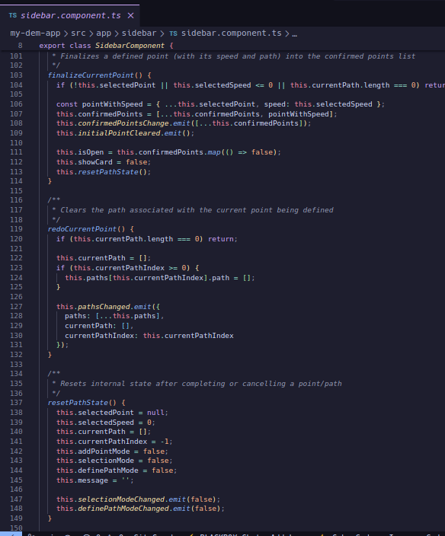

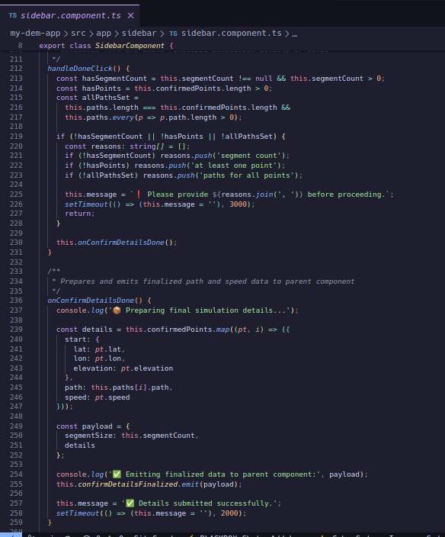

Sidebar.component.html: Uses ngModule to ensure double binding basically supporting on the actions that need to be implemented when the button is pressed in the frontend

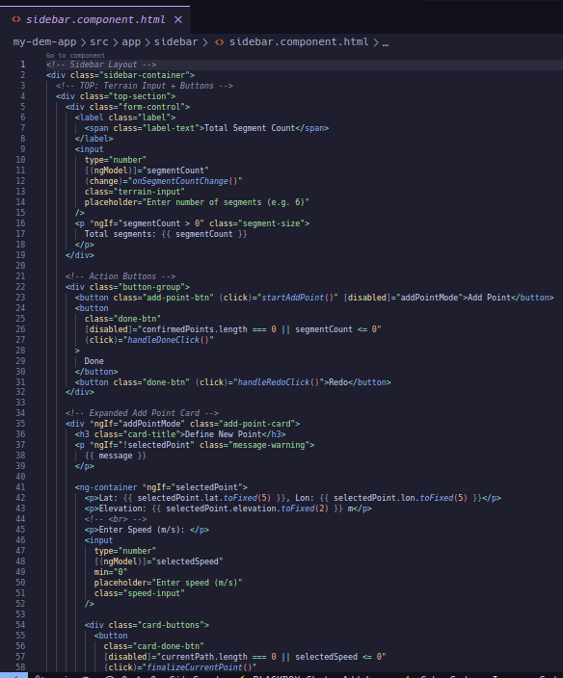

LoadDEM() function: Initially build to render DEM now has been adapted to load DTED-1 formats by combining with another function it is able to extract all required metadata from the binary dted without using any third party sotwares, it then injects data into the shared service from where it is shared everywhere .

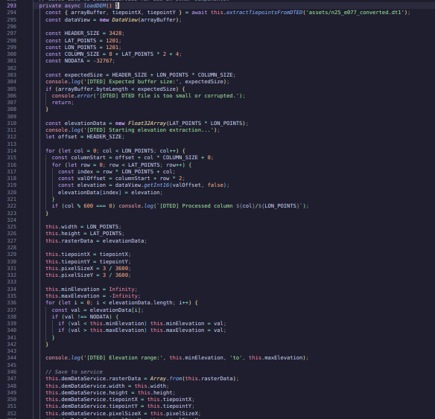

ExtractTiepointsFromDTED():

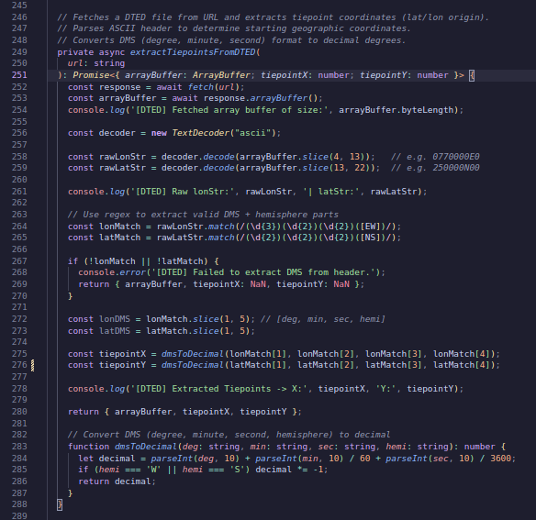

TimeLine.component.ts: Code inside this file is where the magic of the entire project happens it recieves all collected data from the sidebar, then using haversine formula and with the help of interpolate points calculates the complete time for a point to travel the complete path on the DTED-1.

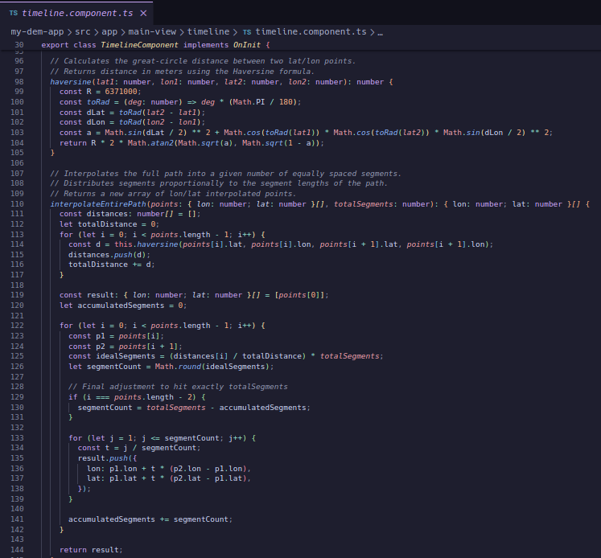

**RESULT AND ANALYSIS**

Interface correctly Loaded and functioning correctly with the provided sample data

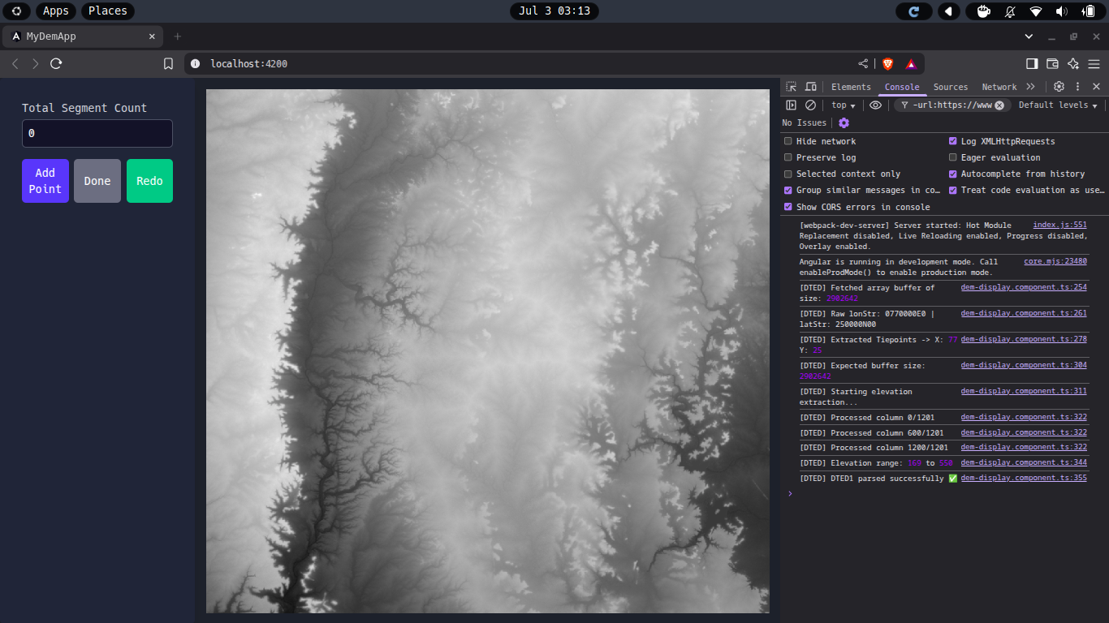

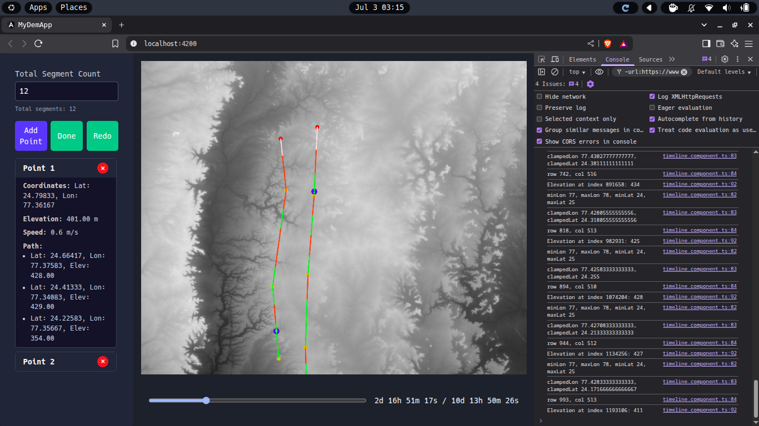

**CONCLUSION**

The project successfully demonstrates how digital elevation data, when combined with intuitive UI elements and dynamic simulation, can be transformed into a powerful tool for visualizing the impact of terrain on movement. By narrowing the focus to a specific DTED-1 dataset and enabling user-defined routes, this application creates an accessible yet technically sound environment for exploring real-world challenges posed by elevation and slope. Through features like animated travel paths, elevation-influenced speed adjustments, and visual slope highlighting, the application turns abstract geospatial data into an interactive experience. Users gain deeper insights into how travel can be affected by the terrain—insights that traditional 2D maps often fail to convey. Whether for education, basic field planning, or understanding topographic influences, this project delivers meaningful interaction with elevation data in a lightweight, browser-based format.

**FUTURE PROSPECTS**

While the current implementation focuses on a single, static terrain file, the underlying framework is scalable and open to many enhancements. In future iterations, support could be added for uploading arbitrary DTED/GeoTIFF files, allowing users to analyze any region of interest globally. Integration with a backend service could also introduce user authentication and persistent storage for saved routes and simulations. Beyond file handling, more advanced simulation logic could be incorporated—such as factoring in vehicle types, energy expenditure on slopes, or terrain roughness. The path definition process could be further refined with tools like automatic path suggestions or real-time elevation graphing. A mobile-responsive design and possible 3D rendering (via Cesium or Three.js) could also enhance the accessibility and visual depth of the simulation.

In essence, this project lays a solid foundation for building a more comprehensive terrain analysis platform, one that can serve not just as an educational tool, but as a practical solution for terrain-aware route evaluation in various domains.

**REFERENCES**

1. **Digital Terrain Elevation Data (DTED)**  
    <https://en.wikipedia.org/wiki/Digital_Terrain_Elevation_Data>
2. **Digital Elevation Model (DEM)**  
    <https://en.wikipedia.org/wiki/Digital_elevation_model>
3. **Understanding DTED Levels and Applications**  
    <https://www.ga.gov.au/scientific-topics/earth-obs/accessing-satellite-imagery/landforms/digital-terrain-models>
4. **Slope Calculation from Elevation Data**  
    <https://desktop.arcgis.com/en/arcmap/10.3/tools/spatial-analyst-toolbox/how-slope-works.htm>
5. **Terrain Analysis in QGIS (for comparison/concept reference)** <https://docs.qgis.org/3.28/en/docs/training_manual/processing/terrain_analysis.html>
6. **USGS EarthExplorer – Source for DTED and DEM Data**  
    <https://earthexplorer.usgs.gov/>
7. **OpenTopography – Accessing Elevation Datasets**  
    <https://opentopography.org/>
8. **NGA DTED Specification Document (PDF)**  
    <https://nsgreg.nga.mil/doc/view?i=2641>
9. **Angular Official Documentation**  
    <https://angular.io/docs>
10. **GeoTIFF File Format (alternative DEM format)**  
     <https://en.wikipedia.org/wiki/GeoTIFF>
11. **DTED Parsing GitHub Repositories** (Node.js and Python)

* <https://github.com/geo-data/parse-dted>
* <https://github.com/georust/gdal> (Rust bindings for GDAL)

1. **RxJS (used in Angular simulation timing)**  
    <https://rxjs.dev/>
2. **Geotiff.js – Library used for parsing elevation files in browser**  
    <https://geotiffjs.github.io/>
3. **Reddit: Data Visualization of Terrain Elevation Projects** <https://www.reddit.com/r/DataIsBeautiful/comments/ntdgbf/terrain_visualization_with_dem_files_in_3d_webgl/>